***Implicit intents***

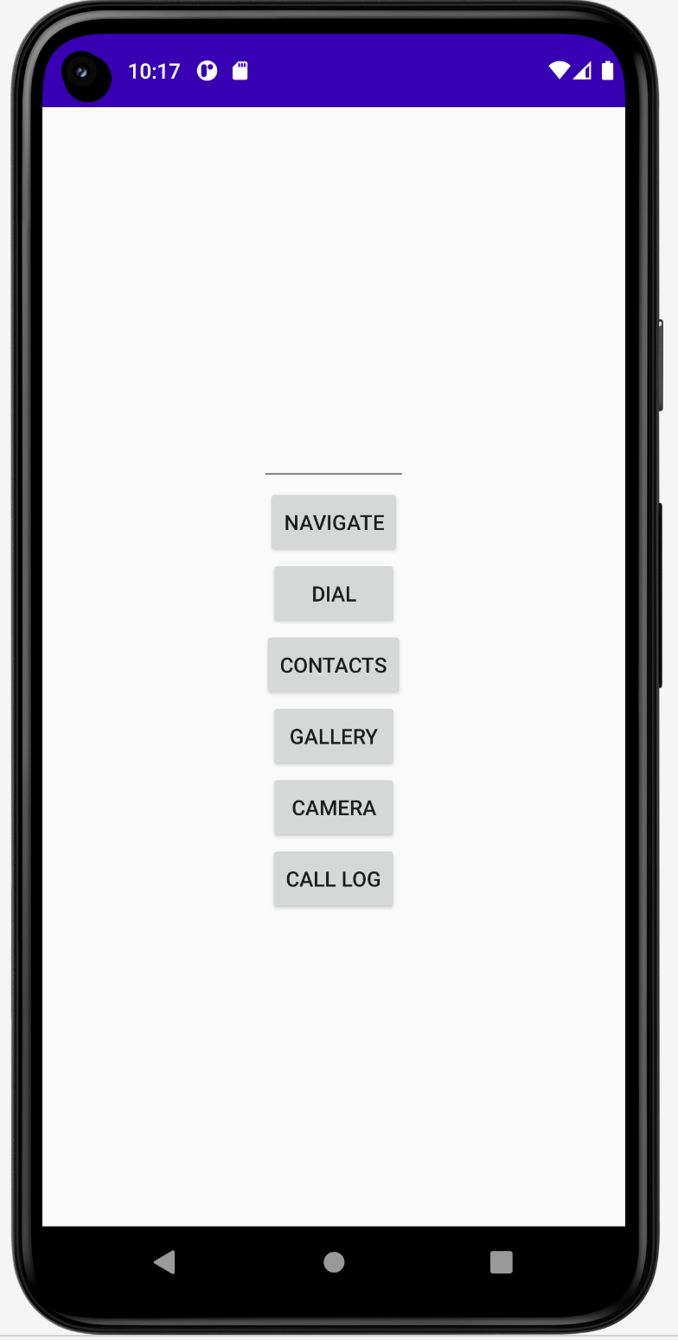

*<?***xml version="1.0" encoding="utf-8"***?>*<**LinearLayout xmlns:android="http://schemas.android.com/apk/res/android"  
 xmlns:app="http://schemas.android.com/apk/res-auto"  
 xmlns:tools="http://schemas.android.com/tools"  
 android:layout_width="match_parent"  
 android:layout_height="match_parent"  
 android:gravity="center"  
 android:orientation="vertical"  
 android:id="@+id/layout"  
 tools:context=".MainActivity"**>  
  
  
 <**EditText  
 android:layout_width="wrap_content"  
 android:layout_height="wrap_content"  
 android:id="@+id/url"  
 android:width="100dp"  
 android:text=""**/>  
  
 <**Button  
 android:id="@+id/button1"  
 android:layout_width="wrap_content"  
 android:layout_height="wrap_content"  
 android:text="Navigate"  
 app:layout_constraintEnd_toEndOf="parent"  
 app:layout_constraintStart_toStartOf="parent"** >  
  
 </**Button**>  
 <**Button  
 android:id="@+id/button2"  
 android:layout_width="wrap_content"  
 android:layout_height="wrap_content"  
 android:text="DIAL"  
 app:layout_constraintEnd_toEndOf="parent"  
 app:layout_constraintStart_toStartOf="parent"** >  
  
 </**Button**>  
 <**Button  
 android:id="@+id/button3"  
 android:layout_width="wrap_content"  
 android:layout_height="wrap_content"  
 android:text="Contacts"  
 app:layout_constraintEnd_toEndOf="parent"  
 app:layout_constraintStart_toStartOf="parent"** >  
  
 </**Button**>  
  
 <**Button  
 android:id="@+id/button5"  
 android:layout_width="wrap_content"  
 android:layout_height="wrap_content"  
 android:text="Gallery"  
 app:layout_constraintEnd_toEndOf="parent"  
 app:layout_constraintStart_toStartOf="parent"** >  
  
 </**Button**>  
 <**Button  
 android:id="@+id/button6"  
 android:layout_width="wrap_content"  
 android:layout_height="wrap_content"  
 android:text="Camera"  
 app:layout_constraintEnd_toEndOf="parent"  
 app:layout_constraintStart_toStartOf="parent"** >  
  
 </**Button**>  
 <**Button  
 android:id="@+id/button7"  
 android:layout_width="wrap_content"  
 android:layout_height="wrap_content"  
 android:text="Call Log"  
 app:layout_constraintEnd_toEndOf="parent"  
 app:layout_constraintStart_toStartOf="parent"** >  
  
 </**Button**>  
  
  
</**LinearLayout**>

**package** com.example.myapplication  
**import** android.content.Intent  
**import** android.net.Uri  
**import** android.os.Bundle  
**import** android.provider.CallLog  
**import** android.provider.ContactsContract  
**import** android.provider.MediaStore  
**import** android.view.View  
**import** android.widget.Button  
**import** android.widget.EditText  
**import** android.widget.Spinner  
**import** androidx.appcompat.app.AppCompatActivity  
**import** androidx.constraintlayout.widget.ConstraintLayout  
**import** com.google.android.material.snackbar.Snackbar  
  
**class** MainActivity : AppCompatActivity() {  
 **override fun** onCreate(savedInstanceState: Bundle?) {  
 **super**.onCreate(savedInstanceState)  
 setContentView(R.layout.*activity_main*)  
  
 **val** et1=findViewById<EditText>(R.id.*url*)*//* **var** b:Button = findViewById(R.id.*button1*)*//navigate* **var** bdial:Button = findViewById(R.id.*button2*)  
 **var** bContacts:Button = findViewById(R.id.*button3*)  
 **var** bgallery:Button = findViewById(R.id.*button5*)  
 **var** bCamera:Button = findViewById(R.id.*button6*)  
 **var** bLog:Button = findViewById(R.id.*button7*)  
  
 b.setOnClickListener **{  
 var** url:String=et1.*text*.toString()  
 **val** url_int2=Intent(Intent.*ACTION_VIEW*, Uri.parse(**"https://+$**url**"**))  
 startActivity(url_int2)  
 **}** bdial.setOnClickListener**{  
 var** i:Intent = Intent(Intent.*ACTION_DIAL*,Uri.parse(**"tel: +919988888888"**))  
 startActivity(i)  
 **}** bContacts.setOnClickListener**{  
 var** idial:Intent = Intent(Intent.*ACTION_VIEW*,ContactsContract.Contacts.*CONTENT_URI*)  
 startActivity(idial)  
 **}** bgallery.setOnClickListener**{  
 var** igallery:Intent = Intent(Intent.*ACTION_VIEW*)  
 igallery.setType(**"image/*"**)  
 startActivity(igallery)  
 **}** bCamera.setOnClickListener**{  
 var** iCamera:Intent = Intent(MediaStore.*ACTION_IMAGE_CAPTURE*)  
 startActivity(iCamera)  
 **}** bLog.setOnClickListener**{  
 var** iLog:Intent = Intent(Intent.*ACTION_VIEW*)  
 iLog.setType(CallLog.Calls.*CONTENT_TYPE*)  
 startActivity(iLog)  
 **}** }  
}